Sunday 23rd May 2021 – Bulwell United Reformed Church
Today is Pentecost Sunday and we celebrate the coming of the Holy Spirit in Acts 2: 1-21. A short service for personal communion focusing on Pentecost is included. Please have your bread & wine/juice ready.

Call to worship
God says: I will pour out my Spirit on all people. THE SPIRIT HAS COME. ALLELUIA!
Christ says: I will ask the Father and he will give you another Counsellor to be with you for ever. THE SPIRIT HAS COME. ALLELUIA!
Come, Holy Spirit, gentle as a dove, burning as fire, powerful as the wind. COME, HOLY SPIRIT, COME.

A prayer of confession
God, your love is unconditional;
your gifts are offered with measureless generosity;
your peace is all-encompassing.
We are sorry for times
when we have put conditions on our willingness to care;
when we have kept what we have for ourselves and refused to share with others;
when we have failed to seek peace and have caused discord.
Forgive us; restore us; renew us by your Spirit of life.
Amen.
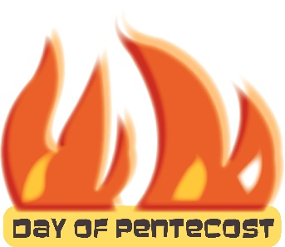
Our Father ………

Song Show Your Power O Lord (Petra)
(527) Show Your Power (Petra) - MVL - roncobb1 - YouTube

Acts 2:1-21 - The Holy Spirit comes at Pentecost
2 When the day of Pentecost came, they were all together in one place. ² Suddenly a sound like the blowing of a violent wind came from heaven and filled the whole house where they were sitting. ³ They saw what seemed to be tongues of fire that separated and came to rest on each of them. ⁴ All of them were filled with the Holy Spirit and began to speak in other tongues as the Spirit enabled them.
⁵ Now there were staying in Jerusalem God-fearing Jews from every nation under heaven. ⁶ When they heard this sound, a crowd came together in bewilderment, because each one heard their own language being spoken. ⁷ Utterly amazed, they asked: ‘Aren’t all these who are speaking Galileans? ⁸ Then how is it that each of us hears them in our native language? ⁹ Parthians, Medes and Elamites; residents of Mesopotamia, Judea and Cappadocia, Pontus and Asia, ¹⁰ Phrygia and Pamphylia, Egypt and the parts of Libya near Cyrene; visitors from Rome ¹¹ (both Jews and converts to Judaism); Cretans and Arabs – we hear them declaring the wonders of God in our own tongues!’ ¹² Amazed and perplexed, they asked one another, ‘What does this mean?’
¹³ Some, however, made fun of them and said, ‘They have had too much wine.’

Peter addresses the crowd
¹⁴ Then Peter stood up with the Eleven, raised his voice and addressed the crowd: ‘Fellow Jews and all of you who live in Jerusalem, let me explain this to you; listen carefully to what I say. ¹⁵ These people are not drunk, as you suppose. It’s only nine in the morning! ¹⁶ No, this is what was spoken by the prophet Joel:
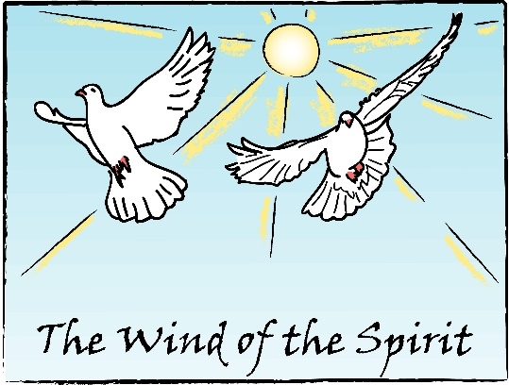
¹⁷ ‘“In the last days, God says,
I will pour out my Spirit on all people.
Your sons and daughters will prophesy,
your young men will see visions,
your old men will dream dreams.
¹⁸ Even on my servants, both men and women,
I will pour out my Spirit in those days,
and they will prophesy.
¹⁹ I will show wonders in the heavens above
and signs on the earth below,
blood and fire and billows of smoke.
²⁰ The sun will be turned to darkness
and the moon to blood
before the coming of the great and glorious day of the Lord.
²¹ And everyone who calls
on the name of the Lord will be saved.” (NIVUK)
Pentecost 2021
The disciples had been preparing themselves to receive the Holy Spirit that Christ had promised them, here they were, gathered together in one place when the manifestations of the Spirit came in wind-like noise, fire-like tongues and the ability to speak different languages – they were spectacular (vv. 1-4). They are not to be downplayed, but neither are they to be seen as an end in themselves. They result not in a private experience of spiritual blessing for the gathered group of disciples, but in public proclamation of the gospel. When the Spirit comes, the disciples are moved outdoors where a crowd can gather (v. 6)
In verses 5-13 we move from the inside to the outside where a great crowd is gathered; from a private experience to a public event. God is revealed to all people (vv. 9-10). The gift of the Spirit does not renew humanity by removing diversity, but by enabling those who speak different languages to ‘hear’ one another. We may have expectations of something overwhelming, a drive towards proclamation, a sudden unity or connectedness just as described in this passage. The source of the church’s power is the Spirit of God. That where God’s spirit is there is unity and a concern for reaching out to others.
The Spirit flowed through the disciples so that they were able to express themselves uninhibitedly and it is the Spirit that removes the blocks to a full and natural expression of what lies in the depths of our hearts – that of the Good News of Jesus Christ. This has challenges for us a as disciples in 2021.
Are we prepared to let the Spirit work within us so that we can shine with the truth? Can we allow the Spirit to come and go freely? Can we allow the Spirit to awaken our God-given gifts and demonstrate the gospel through our natural hospitality? As we live through these challenging times, how can the church portray the love of God and the good news of Jesus in a new way for a new generation?
The source of vitality or energy in the life of a healthy church is our faith in God as revealed in Jesus Christ by the Holy Spirit. In a healthy, brightly lit church, faith is not assumed, it is spoken about, witnessed through our actions and interpreted as central to the task of the church in the community.
As we approach Pentecost this year, the UK is dealing with an enormous vaccination programme the outcome of that being the gradual easing of the lockdowns of the past year. For us in our congregations it signals the beginning of re-establishing our church life. Some churches will have taken the difficult decision to close completely, others to reassess their activities and church life. What may have been ‘normal’ before COVID 19 may now not be so appropriate post COVID. But what we have proved during this past year is our resourcefulness in staying connected, whether that be through Sunday Devotions or the various on-line services. We also have proved that our faith lives on through this pandemic, that despite feeling weary at times, we’ve put our trust in God, allowed our batteries to be topped up and ready for the energy needed in order to be receptive to the Spirit at work in our lives and in the life of the church.
On this day of Pentecost, we are being called to use our God-given gifts and to be receptive to the Spirit at work in our lives, so that together we can serve God, serve one another and help people to experience God’s love.

Prayers of intercession
Holy Spirit of peace,
we pray for homes and nations where there is discord and conflict.
Pour out your breath of peace that people may listen to each other;
may respect one another; may honour each other.
Holy Spirit, hear us.
Come, Holy Spirit, come.
Holy Spirit of hope,
we pray for those who live in despair; for those who can see no purpose in their lives;
for those who cannot see a way ahead; for those who feel completely alone.
Holy Spirit, hear us.
Come, Holy Spirit, come.
Holy Spirit of unity,
we pray for your Church, for its ministry to the faithful; for its mission to the world.
May the Spirit of Pentecost breathe upon us, that we may witness to the world
the comfort, meaning and love that you offer. Heal our differences and make us one in you.
Holy Spirit, hear us.
Come, Holy Spirit, come.
In the name of our Saviour we pray.
Amen.

Please add your prayers for others you wish to pray for today . . .

Song There is a Redeemer sung by Keith Green - video:
https://www.youtube.com/watch?v=C_vzXtPnZ9Y

HOLY COMMUNION – PENTECOST
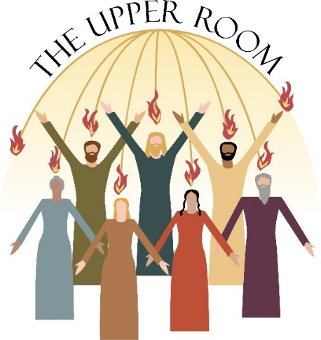
Prayer of Thanksgiving
We give you all thanks and praise, O God,
for you have amazed us with your deeds of power.
In these last days you sent your child, Jesus the Christ,
to speak your words of mercy and peace.
Though he was killed, you raised him to new life,
and now he comes to all who are thirsty,
pouring out the new wine of the Spirit,
intoxicating us with visions and dreams,
awakening within us your marvellous gifts
of wisdom, faith, healing, prophesy and discernment,
and firing our tongues with everlasting songs of joy.
The Sharing of the Bread and the Wine
We give thanks to you, O God, that you cause the vine to yield fruit. We bless you for Christ, the true vine, whose blood was poured out for us. By your Holy Spirit sanctify us and this wine, that the cup which we bless may be to us the communion of the blood of Christ, and that through abiding in him we may bear fruit that shall last.
Eat this bread. It is the bread of life.
Drink this wine. It is the cup of blessing.
Prayer after communion
Loving God, you have fed us generously at this table, as we have remembered Jesus and rejoiced that he is with us today. We are ready now to follow him, and to be your people in the world. May your Holy Spirit show us the way, make us holy and fill us with love.

A sending out prayer
May the power of the Spirit challenge you.
May the peace of the Spirit comfort you. May the presence of the Spirit enable you to live in love and service in the name of Christ.
Amen.

